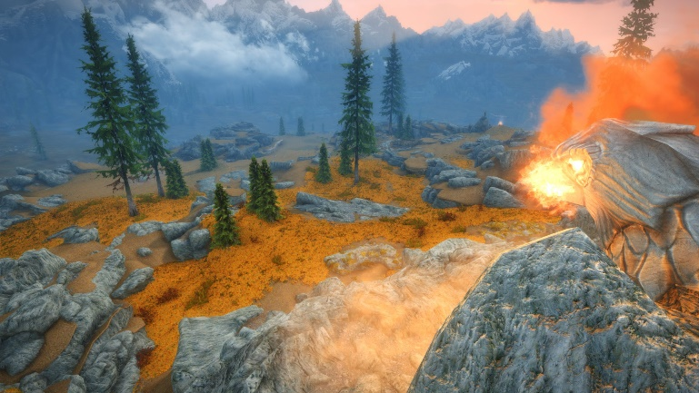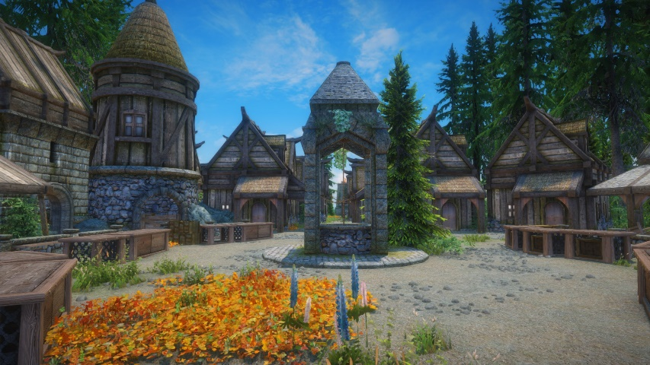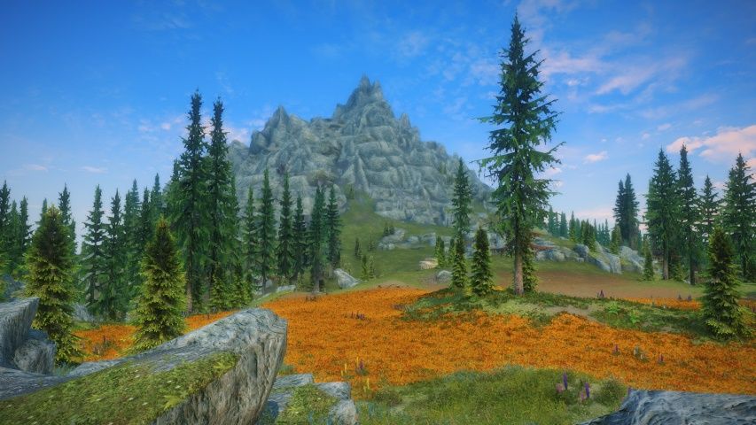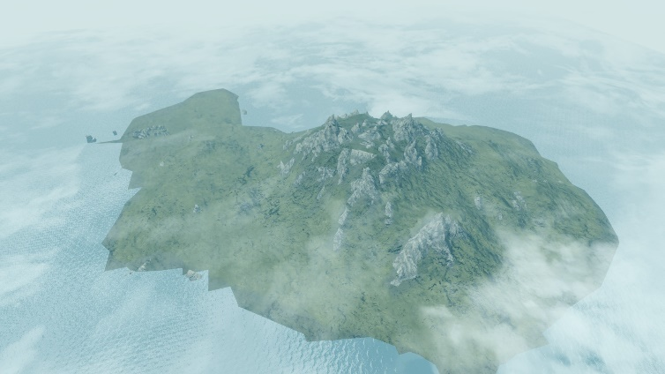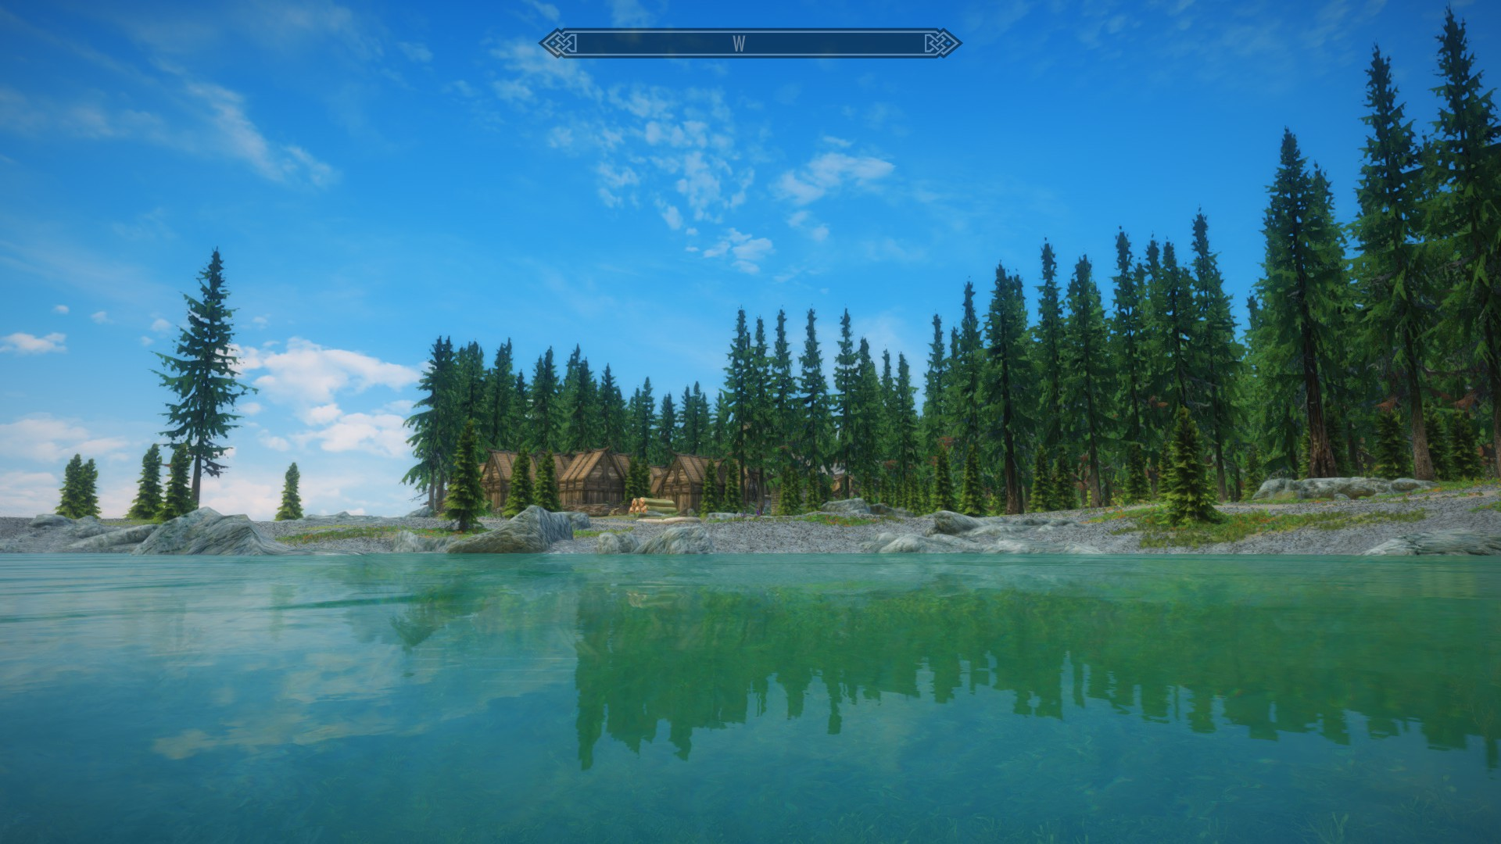

I also played around with removing all signs of human life from the game, again, for fun. I had eventually cleared all of the Whiterun Region, taking out every town and fort and replacing the terrain to look more natural.

The city of whiterun with only the bird statue remaining

Around the end of 2019/beginning of 2020 I spent some time building worlds and environments as mods for the game Skyrim. I imported several heightmaps into the game, which as it turns out is a rather involved process, and began significantly developing one of them. This one turned into an abandoned town on a lush forested island.

Town view of the most developed island

Environment view of the most developed island

Map view of the most developed island

**SKYRIM MODDING**